Communication About Student Learning
6

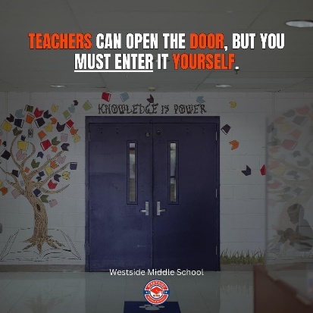

Westside Middle School is committed to serving the community through consistent communication with families about student learning.

WE will do this by:
- Weekly and monthly check ins from teachers on students via email and phone calls.

- Updates on the school website and current grades and attendance in Power School

- Meetings and conferences on understanding student progress and any school policy changes

- Parent Teacher Conferences in October and March

Do you have questions about your child’s progress?

Contact your child’s teacher by phone (901) 440-4011or email. Email addresses are listed in PowerSchool and on the school website at: www.fraysercs.org

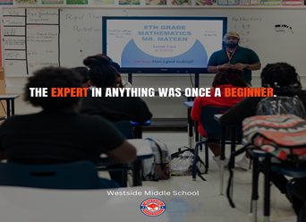
5
Westside Middle School
2024-2025
7
School-Parent Compact

What is a School-Parent Compact?
A School-Parent Compact is a shared agreement that describes how parents, children, and the school will work together to support the child’s learning. The School-Parent Compact should be shared at the beginning of the school year with parents and then reviewed during conferences. Title I parents have the right, by law, to be involved in the development and revision of the School-Parent Compact. The Compact has 3 sections - parent section, student section, and school section. The school section must include 6 required components:
  - Provide high-quality curriculum and instruction
  - Hold parent-teacher conferences
  - Provide parents with reports on their child’s progress
  - Provide parents reasonable access to staff
  - Provide parents opportunities to volunteer
  - Ensure regular two-way meaningful communication between family members and staff, to the extent practicable, in a language family member can understand
Jointly Developed
The families, students, and staff at Westside Middle School developed this School-Parent Compact. Teachers suggested ways for parents to assist their child with homework as well as a daily routine for this. Families asked for more communication and tutoring hours by the staff, Students stated they would love more afterschool tutoring, training on technology and how to utilize more technologies for in class and homework assignments. Families are welcome to contribute comments and suggestions through out the school year. If you would like to contribute, please contact Marcus Shead at marcus.shead@fraysercs.org or (901)440-4011.

Building Partnerships
4
Join Us!!!!
Title 1 Night September 5, 2024 @5PM
Parent Teacher Conference/Math and Science Night October 25, 2024 @5PM
Pastries with Parents November 20, 2024 @8:15am

MORE FAMILY and STUDENT EVENTS are posted on our school facebook page and our school website at www.fraysercs.org

Any parent that would like to volunteer at Westside Middle School please contact Mrs. Waltina Pearson at the school (901) 440-4011

Chiquita Perry
(901)440-4011
www.fraysercs.org

Our Goals for Student Achievement
1A
District Goals
- 80% of students are college or career ready
- 90% of students matriculate to next grade level
- 100% of students graduate on time and enroll in a post-secondary opportunity
School Goals
- Improve math proficiency and increase the percentage of 6th to 8th grade students meeting or exceeding expected growth 4% to 8% on TNReady Assessment for the 2024 – 2025 school year.
- Improve Literacy proficiency and increase the number of 6th to 8th grade students meeting or exceeding expected growth from 6% to 8% on the TNReady Assessment for the 2024 – 2025 school year.
- Increase parent and student satisfaction with the school environment to 85% as measured by our anonymous parent/student survey.
Teachers, families, students – Together for Success
In the Classroom  1B  Teachers in the classroom will work with families to support students’ academic success. Some of our key connections with families will be:  - Teachers will provide a syllabus for each nine weeks and an intense rigorous but fun daily learning experience.  - Offer 2 free Family Fun Nights per year concentrating on what students have learn thus far in the content classes and how math and science ties together as well as how English and Social Studies ties together,  - Our Newsletter will include essential homework tips and assessment preparation tips. |  | At Home  2  Westside families joined staff to develop ideas about how families can support student academic success.  - Check student emails and PowerSchool every day when the child come home and discuss what learning took place that day.  - Email teachers between 5PM and 7Pm for any homework assistance.  - Try to attend all Educational Nights and Parent Conferences,  - Look for the monthly newsletter and important school updates on the school website and from Parent Square Messenger.
Students
3
Westside students joined staff and families to develop ideas about how they can be successful students and show growth academically this year.

- Talk with my family about what I leaned each day as well what I am struggling with academically.

- Bring home all parent communication that the school gives out to my parent.

- Keep a task calendar of my assignments that are due and upcoming assessments.

- Help others in areas I am academically strong in and ask for help in academic areas where I have weaknesses.

